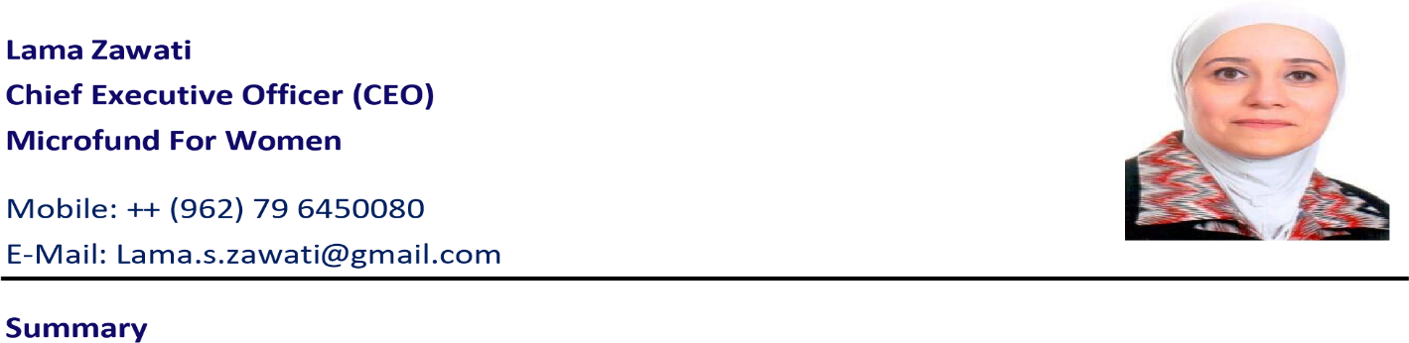

**Lama Zawati**

**Mobile : ++(962)796450080**

**E-mail: Lama.s.zawati@gmail.com**

**__________________________________________________________________________**

**Professional Summary**

Visionary senior executive with over 26 years of progressive leadership experience in finance, strategic planning, fintech, digital transformation, SME development, and operational excellence. Renowned for spearheading innovation, fostering financial inclusion, and empowering teams to deliver exceptional results. A proven leader in integrating fintech solutions to drive sustainable growth and social impact, coupled with expertise in stakeholder management and partnership building.

_________________________________________________________________________________

**Key Skills**

* Strategic Planning and Execution
* Digital Transformation and Fintech Integration
* Financial Management and Analysis
* SME Development and Entrepreneurship
* Stakeholder Engagement and Partnership Building
* Risk Management and Regulatory Compliance
* Team Leadership and Talent Development
* Project Management and Operational Excellence
* Spin-Off Transactions and Business Structuring

**Qualifications**

* Executive MBA - American University of Beirut (2024–2025)
* Data Science for Business - Harvard Business School Online (2021)
* IFC Corporate Directors Certification Program - International Finance Corporation (2020)
* Strategic Leadership in Inclusive Finance - Harvard Business School Executive Education (2019)
* Back to Boulder: Enhancing Strategic Relevance in Microfinance - (IFC)-Washington, DC, 2019
* The Boulder Microfinance Training Program (Concentration in Management) - Boulder Institute of Microfinance / ITC - Turin, Italy, July 2013
* Advanced Leadership & Coaching - Oxford University & Creative Métier - UK, June 2012
* Advanced Leadership - Wharton School, University of Pennsylvania - USA, April 2012
* Commercial Micro Banking Academy - Frankfurt School of Finance & Management - Frankfurt, Germany, July 2011
* Excellence in Risk Management for Microfinance - Luxembourg, November 2010
* B.Sc. in Advanced Accounting & Finance - Yarmouk University – Jordan, 1993

**Professional Experience**

**Chief Executive Officer**

***MicroFund for Women (MFW), Jordan* | *Nov 2021 – Nov 2024***

* Defined and executed strategic vision, driving financial sustainability while advancing social missions.
* Spearheaded digital financial solutions and optimized operational workflows.
* Cultivated high-impact partnerships with donors, regulators, and investors.
* Delivered measurable financial and social outcomes, achieving business plan targets.

**Deputy General Manager**

***MicroFund for Women (MFW), Jordan* | *Jan 2019 – Oct 2021***

* Directed strategic plans for financial and non-financial services, achieving organizational growth targets.
* Strengthened partnerships and enhanced organizational visibility on local and global stages.
* Fostered a high-performance culture, coaching teams to exceed performance benchmarks.

**Deputy General Manager for Finance & Administration**

***MicroFund for Women (MFW), Jordan | Jan 2016 – Dec 2018***

* Oversaw financial operations, IT systems, and compliance frameworks.
* Managed budgets, streamlined procurement, and enhanced operational efficiency.
* Cultivated relationships with key stakeholders, ensuring alignment with strategic goals.

**Chief Financial Officer (CFO)**

***MicroFund for Women (MFW), Jordan* | *Jan 2009 – Dec 2015***

* Led financial strategy, budgeting, and investment planning to optimize institutional growth.
* Enhanced financial reporting accuracy and maintained compliance with global standards.
* Drove cost-efficiency measures, securing financial sustainability.

**Financial Controller**

***Orange - Enterprise Business unit (Jordan Telecom Group), Jordan* | *Sep 2007 – Dec 2008***

* Managed financial planning, reporting, and performance monitoring.
* Delivered actionable insights through in-depth financial analysis and KPI optimization.
* Ensured alignment of financial objectives with strategic business plans.

**Board Memberships & Leadership Roles**

* Chairperson – Tanmeyah, The Jordanian Microfinance Network
* Board Member and Audit Committee Member – Hulool-Uwallet, Mobile Payment Solutions Company
* Contributor – Jordan’s Economic Modernization Vision Initiative (2022)
* Active Member – Business Professional Women (BPW), Jordan

**Achievements**

* Expanded MFW's portfolio achieving 35% over the past 3 years, and enhanced client outreach, achieving regional leadership.
* Spearheaded organizational growth by expanding the MicroFund for Women’s (MFW) client base, achieving a 12% increase in active users over three years.
* Established and managed strategic partnerships with renowned international organizations, including IFC, EBRD, EIB, Sanad, and GIZ.
* Secured $15 million in funding from international stakeholders such as EBRD, EIB, Sanad Finance in Motion, and Triodos, driving organizational initiatives and operational growth.
* Optimized operations, achieving a 10% cost reduction through effective financial planning and streamlined processes during tenure as CFO.
* Negotiated financial agreements that reduced borrowing costs by 3%, enhancing financial stability and growth potential.
* Launched fintech solutions that drove 85% adoption of digital lending disbursements and increased e-channel and digital payment usage by 48%, advancing financial inclusion for underserved populations.
* Implemented a digital transformation strategy, cutting lending processing times from three days to one hour, dramatically enhancing client satisfaction.
* Oversaw the disbursement of over $206 million over 3 years in microloans, positively impacting the livelihoods of 134K clients in underserved communities.
* Enhanced financial literacy among clients, leading to 10% improvement in loan repayment rates.
* Developed and executed long-term strategies that elevated MFW’s visibility locally, regionally, and internationally, solidifying its reputation as a market leader.
* Cultivated a high-performance culture, mentoring over 33 employees into leadership roles, ensuring sustainable talent development and organizational growth.
* Introduced advanced risk management frameworks, reducing operational risks and ensuring compliance with Central Bank of Jordan regulations.